DATUK SERI DR. MOHD NIZOM SAIRI

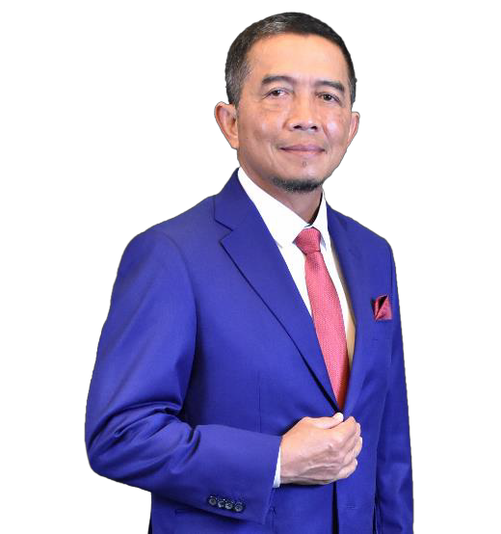

Datuk Seri Dr. Mohd Nizom Sairi is a distinguished tax expert with an illustrious career primarily anchored in his longstanding service with the Inland Revenue Board of Malaysia (IRBM). His academic journey commenced with a Bachelor of Science degree from Laurentian University, Canada, followed by a Master's in Information System Management from Lawrence Technological University, USA, and culminating in a doctorate from the Swiss School of Management. His academic excellence is further highlighted by honorary professorships at the University of Cyberjaya and UNITAR International University.

Over a span of 37 years at IRBM, Nizom has demonstrated profound expertise in the operations and administration of direct taxes in Malaysia, which paved the way for his ascension to the CEO/Director General position. His career trajectory includes pivotal roles such as Director of Compliance, Investigation, and the Malaysian Tax Academy, along with significant leadership positions culminating in his current role where he has been a cornerstone in digitalizing and transforming Malaysia's tax administration.

Nizom's contributions extend beyond national borders through his active engagement in prestigious international tax forums with organizations like OECD, IBFD, IMF, and many others, showcasing his global tax policy influence. His leadership is recognized internationally, as evidenced by his roles as Chairman of the Commonwealth Association of Tax Administrators and Head of the Executive Council for the Association of Tax Authorities of Islamic Countries.

A proponent of a trust-based tax environment, Nizom advocates for compliance through awareness, education, and enhanced services, embodying his commitment to constructive stakeholder engagement. His dedication to social responsibility is evident in his participation in various CSR initiatives, contributing significantly to environmental conservation and community welfare. Nizom's personal life reflects his professional ethos, with a preference for golf as a leisure activity, underscoring his well-rounded personality.

